Plane Geometry
# Source: AI Source: Provided by: [Data Path: Persons Table -> ID Column: 1, Name_En Column: Motasem Essam] -> From: [ChatGPT] on [7/25/2026]
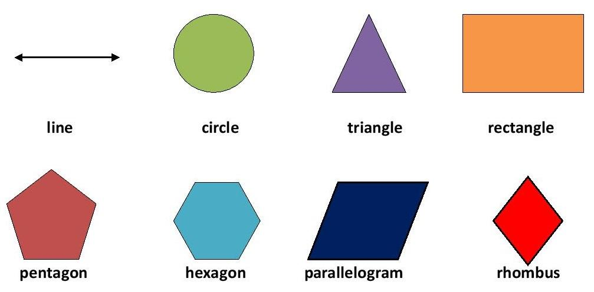
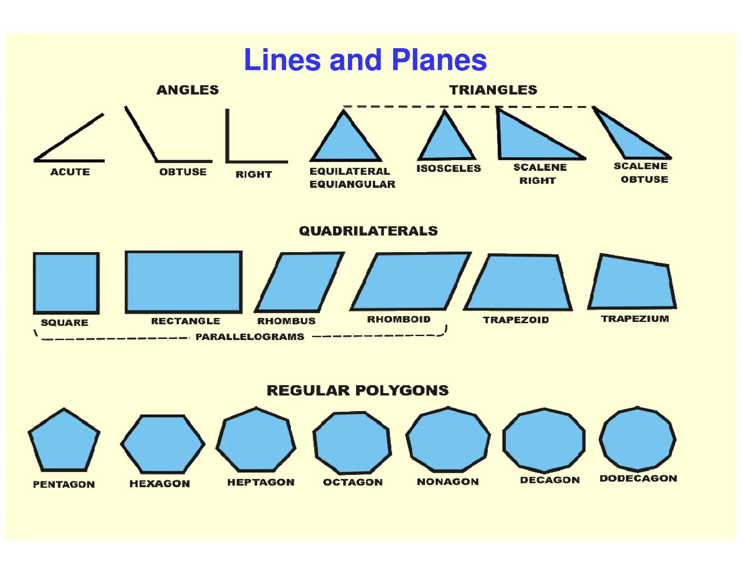
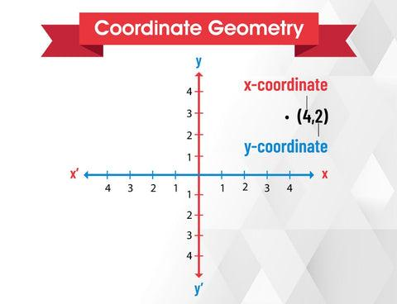
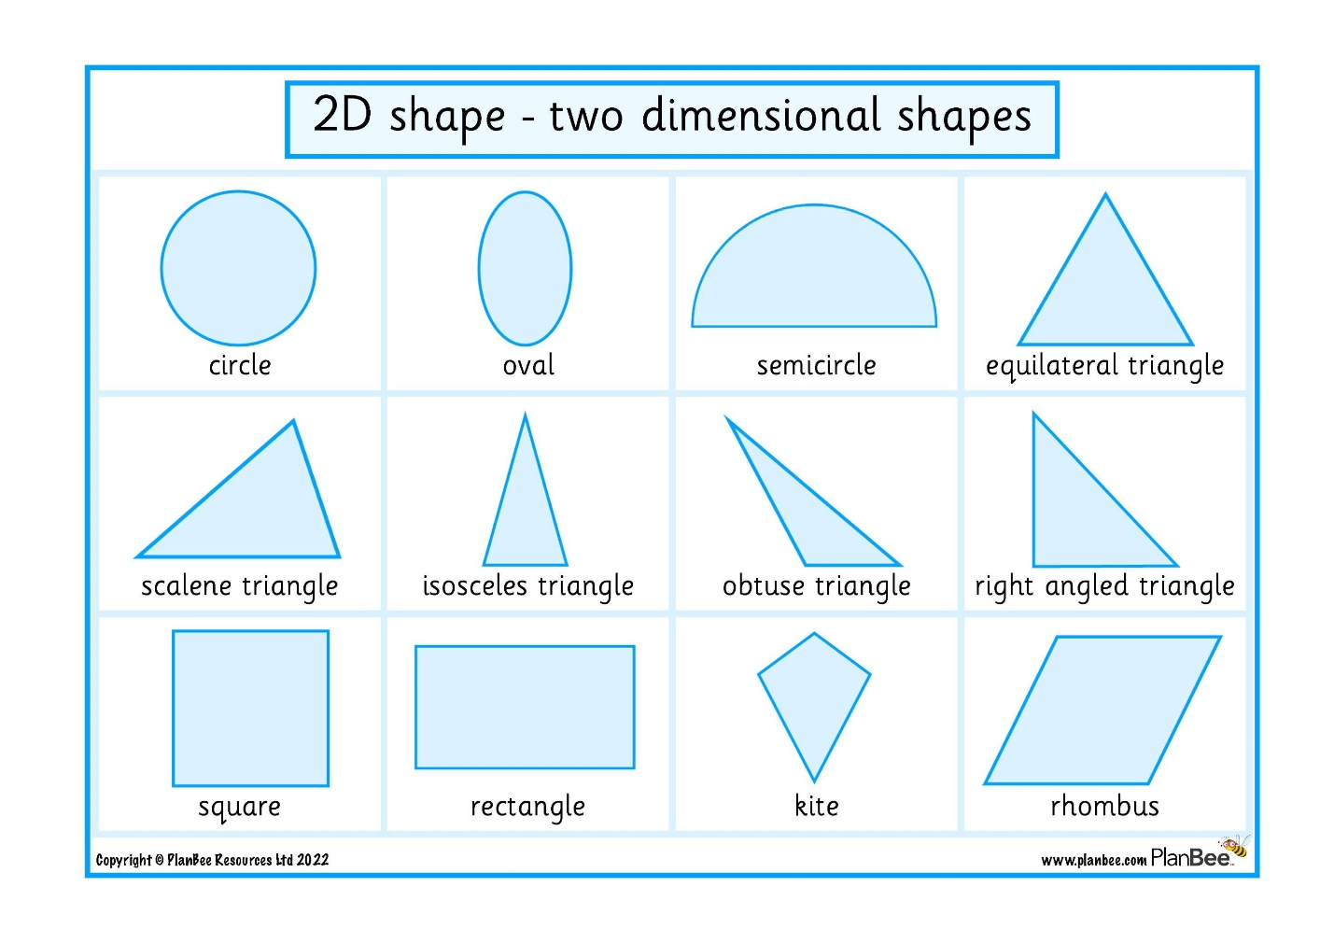
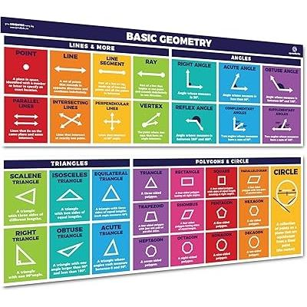

Definition
# Source: AI Source: Provided by: [Data Path: Persons Table -> ID Column: 1, Name_En Column: Motasem Essam] -> From: [ChatGPT] on [7/25/2026]
Plane Geometry, also called Two-Dimensional (2D) Geometry, is the branch of geometry that studies flat figures that have length and width but no thickness or depth.
All objects in plane geometry lie on a single flat surface (plane).

Purpose
# Source: AI Source: Provided by: [Data Path: Persons Table -> ID Column: 1, Name_En Column: Motasem Essam] -> From: [ChatGPT] on [7/25/2026]
Plane geometry is used to:
- Study two-dimensional shapes.
- Measure lengths, angles, perimeters, and areas.
- Analyze geometric relationships.
- Solve construction and design problems.
- Support engineering, architecture, mapping, and computer graphics.

Fundamental Elements
# Source: AI Source: Provided by: [Data Path: Persons Table -> ID Column: 1, Name_En Column: Motasem Essam] -> From: [ChatGPT] on [7/25/2026]
Plane geometry is built from several basic geometric elements.

Point
# Source: AI Source: Provided by: [Data Path: Persons Table -> ID Column: 1, Name_En Column: Motasem Essam] -> From: [ChatGPT] on [7/25/2026]
A point represents an exact location.
Properties:
- No length
- No width
- No thickness
Notation:
$$A, B, P$$

Line
# Source: AI Source: Provided by: [Data Path: Persons Table -> ID Column: 1, Name_En Column: Motasem Essam] -> From: [ChatGPT] on [7/25/2026]
A straight path extending infinitely in both directions.
Properties:
- Infinite length
- No thickness
Notation:
$$\overset{↔}{AB}$$

Line Segment
# Source: AI Source: Provided by: [Data Path: Persons Table -> ID Column: 1, Name_En Column: Motasem Essam] -> From: [ChatGPT] on [7/25/2026]
A part of a line with two endpoints.
Notation:
$$\overset{‾}{AB}$$

Ray
# Source: AI Source: Provided by: [Data Path: Persons Table -> ID Column: 1, Name_En Column: Motasem Essam] -> From: [ChatGPT] on [7/25/2026]
A line that begins at one endpoint and extends infinitely in one direction.
Notation:
$$\vec{AB}$$

Plane
# Source: AI Source: Provided by: [Data Path: Persons Table -> ID Column: 1, Name_En Column: Motasem Essam] -> From: [ChatGPT] on [7/25/2026]
A flat surface extending infinitely in all directions.
Properties:
- Length
- Width
- No thickness

Angles
# Source: AI Source: Provided by: [Data Path: Persons Table -> ID Column: 1, Name_En Column: Motasem Essam] -> From: [ChatGPT] on [7/25/2026]
An angle is formed when two rays meet at a common endpoint (vertex).
Types include:
- Acute Angle
- Right Angle
- Obtuse Angle
- Straight Angle
- Reflex Angle
- Full Angle

Common Two-Dimensional Shapes

Triangle
# Source: AI Source: Provided by: [Data Path: Persons Table -> ID Column: 1, Name_En Column: Motasem Essam] -> From: [ChatGPT] on [7/25/2026]
A polygon with three sides.
Types by sides:
- Equilateral
- Isosceles
- Scalene
Types by angles:
- Acute
- Right
- Obtuse

Quadrilaterals
# Source: AI Source: Provided by: [Data Path: Persons Table -> ID Column: 1, Name_En Column: Motasem Essam] -> From: [ChatGPT] on [7/25/2026]
Four-sided polygons.
Examples:
- Square
- Rectangle
- Parallelogram
- Rhombus
- Trapezoid
- Kite

Circle
# Source: AI Source: Provided by: [Data Path: Persons Table -> ID Column: 1, Name_En Column: Motasem Essam] -> From: [ChatGPT] on [7/25/2026]
A set of all points equally distant from a center.
Main parts:
- Radius
- Diameter
- Circumference
- Chord
- Arc
- Sector

Polygons
# Source: AI Source: Provided by: [Data Path: Persons Table -> ID Column: 1, Name_En Column: Motasem Essam] -> From: [ChatGPT] on [7/25/2026]
Closed figures with straight sides.
Examples:
- Pentagon
- Hexagon
- Heptagon
- Octagon
- Nonagon
- Decagon

Measurements in Plane Geometry
# Source: AI Source: Provided by: [Data Path: Persons Table -> ID Column: 1, Name_En Column: Motasem Essam] -> From: [ChatGPT] on [7/25/2026]
Plane geometry commonly measures:
- Length
- Distance
- Angle
- Perimeter
- Area
- Radius
- Diameter
- Circumference

Common Formulas
# Source: AI Source: Provided by: [Data Path: Persons Table -> ID Column: 1, Name_En Column: Motasem Essam] -> From: [ChatGPT] on [7/25/2026]
Rectangle Area
$$A=l×w$$

Square Area
$$A=s^{2}$$

Triangle Area
$$A=\frac{1}{2}bh$$

Circle Area
$$A=πr^{2}$$

Circle Circumference
$$C=2πr$$

Polygon Interior Angle Sum
$$\left(n-2\right)×{180}^{∘}$$
where:
- $n$= number of sides

Geometric Relationships
# Source: AI Source: Provided by: [Data Path: Persons Table -> ID Column: 1, Name_En Column: Motasem Essam] -> From: [ChatGPT] on [7/25/2026]
Plane geometry studies relationships such as:
- Parallel lines
- Perpendicular lines
- Intersecting lines
- Congruence
- Similarity
- Symmetry
- Transformations
  - Translation
  - Rotation
  - Reflection
  - Dilation

Coordinate Geometry
# Source: AI Source: Provided by: [Data Path: Persons Table -> ID Column: 1, Name_En Column: Motasem Essam] -> From: [ChatGPT] on [7/25/2026]
Plane geometry often uses the Cartesian coordinate system.
A point is represented by:
$$\left(x , y\right)$$
Applications include:
- Distance between points
- Midpoint
- Line equations
- Graphing

Applications
# Source: AI Source: Provided by: [Data Path: Persons Table -> ID Column: 1, Name_En Column: Motasem Essam] -> From: [ChatGPT] on [7/25/2026]
Plane geometry is used in:
- Architecture
- Civil engineering
- Mechanical design
- Surveying
- Cartography
- Interior design
- Computer graphics
- Robotics
- Manufacturing
- Education

Advantages
# Source: AI Source: Provided by: [Data Path: Persons Table -> ID Column: 1, Name_En Column: Motasem Essam] -> From: [ChatGPT] on [7/25/2026]
Plane geometry:
- Develops spatial reasoning.
- Supports accurate measurement.
- Simplifies engineering design.
- Improves problem-solving skills.
- Forms the basis for advanced geometry.

Limitations
# Source: AI Source: Provided by: [Data Path: Persons Table -> ID Column: 1, Name_En Column: Motasem Essam] -> From: [ChatGPT] on [7/25/2026]
Plane geometry:
- Represents only flat objects.
- Cannot describe three-dimensional solids.
- Assumes ideal geometric figures.

Comparison with Solid Geometry
# Source: AI Source: Provided by: [Data Path: Persons Table -> ID Column: 1, Name_En Column: Motasem Essam] -> From: [ChatGPT] on [7/25/2026]
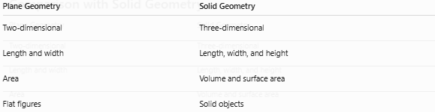
Plane Geometry | Solid Geometry
Two-dimensional | Three-dimensional
Length and width | Length, width, and height
Area | Volume and surface area
Flat figures | Solid objects

Key Points
# Source: AI Source: Provided by: [Data Path: Persons Table -> ID Column: 1, Name_En Column: Motasem Essam] -> From: [ChatGPT] on [7/25/2026]
- Plane Geometry studies two-dimensional figures.
- It includes:
  - Points
  - Lines
  - Angles
  - Triangles
  - Quadrilaterals
  - Circles
  - Polygons
- Common measurements include:
  - Length
  - Angle
  - Perimeter
  - Area
- It forms the foundation for engineering, architecture, surveying, mapping, and mathematics.

Conclusion
# Source: AI Source: Provided by: [Data Path: Persons Table -> ID Column: 1, Name_En Column: Motasem Essam] -> From: [ChatGPT] on [7/25/2026]
Plane Geometry (2D Geometry) is the branch of mathematics that studies flat shapes and their properties on a two-dimensional plane. It provides the concepts, relationships, and formulas needed to measure and analyze lengths, angles, perimeters, and areas. As a fundamental area of mathematics, plane geometry supports engineering, architecture, surveying, cartography, computer graphics, design, and scientific research, serving as the foundation for many advanced mathematical and technical disciplines.

